**Data Flow Diagra****ms:**

Project Design Phase-II

Data Flow Diagram & User Stories

|  |  |
| --- | --- |
| Date | 16 October 2022 |
| Team ID | PNT2022TMID51219 |
| Project Name | AI-Powered Nutrition Analyzer For Fitness  Enthusiasts |
| Maximum Marks | 4 Marks |

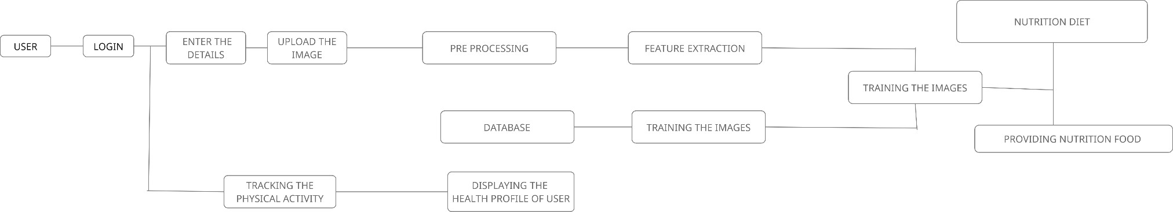

**User Stories**

Use the below template to list all the user stories for the product.

|  |  |  |  |  |  |  |
| --- | --- | --- | --- | --- | --- | --- |
| **User Type** | **Functional**  **Requirement (Epic)** | **User Story Number** | **User Story / Task** | **Acceptance criteria** | **Priority** | **Release** |
| Customer (Mobile user) | Registration | USN-1 | As a user, I can register for the application by entering my email, password, and  confirming my password. | I can access my account  / dashboard | High | Sprint-1 |
|  |  | USN-2 | As a user, I will receive confirmation email once I have registered for the  application | I can receive confirmation email & click confirm | High | Sprint-1 |
|  |  | USN-3 | As a user, I can register for the application through Facebook | I can register & access the dashboard with Facebook Login | Low | Sprint-2 |
|  |  | USN-4 | As a user, I can register for the application through Gmail | I can register and acces the dashboard with  gmail | Medium | Sprint-1 |
|  | Login | USN-5 | As a user, I can log into the application by entering email & password | I can login using my email and password | High | Sprint-1 |
|  | Dashboard | USN-6 | As a user I can upload food image as input | I can use my camera or  my files to upload image | Medium | Sprint-1 |
|  |  | USN-7 | As a user I can give my diet details and with that app provides nutrients recommendation | I can enter my information and allow app to access details | High | Sprint-2 |
| Customer (Web user) | Registration | USN-1 | As a user, I can register for the application by entering my email, password, and confirming my password. | I can access my account  / dashboard | High | Sprint-1 |
|  |  | USN-2 | As a user, I will receive confirmation email once I have registered for the application | I can receive confirmation email & click confirm | High | Sprint-1 |
|  |  | USN-3 | As a user, I can register for the application through Facebook | I can register & access the dashboard with Facebook Login | Low | Sprint-2 |
|  |  | USN-4 | As a user, I can register for the application  through Gmail | I can register and  access the dashboard | Medium | Sprint-1 |

|  |  |  |  |  |  |  |
| --- | --- | --- | --- | --- | --- | --- |
|  |  |  |  | with gmail |  |  |
|  | Login | USN-5 | As a user, I can log into the application by entering email & password | I can login using my email and password | High | Sprint-1 |
|  | Dashboard | USN-6 | As a user I can upload food image as input | I can use my camera or  my files to upload image | High | Sprint-1 |

|  |  |  |  |  |  |  |
| --- | --- | --- | --- | --- | --- | --- |
| **User Type** | **Functional Requiremen t (Epic)** | **User Story Number** | **User Story / Task** | **Acceptance criteria** | **Priority** | **Release** |
|  |  | USN-7 | As a user I can give my diet details and with that app provides nutrients recommendation | I can enter my information and allow app to access details | High | Sprint-2 |
| Customer Care Executive | Mail | USN-1 | As a customer care executive, I can access customer’s information and to solve their queries and issues | I can access I can access customer’s information and to solve their queries and issues | Medium | Sprint-2 |
| Administrator | Dashboard | USN-1 | As a admin I can track sleep and physical activity of user | I can track user activities | High | Sprint-1 |
|  |  | USN-2 | As a admin I can display the health profile  of user | I can display health profile | Medium | Sprint-2 |
|  |  | USN -3 | As a admin I can recommend nutritional content and diet to the user | I can provide nutritional diet | High | Sprint-2 |